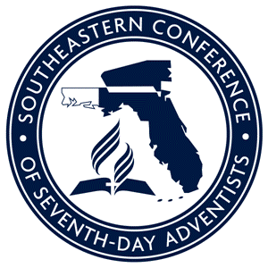
SEC Ministry Subsidies Now Available for 2019
Women’s Ministries

Southeastern Conference introduces a new program that offers subsidies to various ministries within the local church. The purpose of these funds is to help your church execute a mission-driven model. A mission-driven church focuses all of its activities towards fulfilling every segment of its mission of sharing hope and restoring wholeness. To achieve this, we must REACH: Revival and transformation; Education for discipleship; Alignment within the body; Community outreach and evangelism; and Healthy leadership and management.
Please complete the preliminary information and see subsidy requirements listed below.
Leader Name: Department:
Mailing Address:
Phone Number: Email Address:
Church: Pastor:

Is your church registered as Mission-driven? Yes No
Is your church up to date with conference remittances? Yes No
I understand that funds must be used for mission. Yes No
I understand that funds are available on a first come, first served basis. Yes No
I understand that funds are renewable if criteria for current year is met. Yes No

The goal of the SEC Women’s Ministries Department is to Nurture and Empower women and provide Outreach opportunities to win souls for the kingdom of God. We will always be intentional about including every woman in our programs and activities, and sharing God’s love with His daughters.

Requirements for $1000 Subsidy:
- There must be an active women’s ministries department in your church.
- Leaders must be intentional about making women’s ministries a ministry for every woman.
- Leaders must include programming and activities for girls and teens.
- Leaders must be up to date in submission of monthly reports.
DISTRIBUTION OF FUNDS
- Applications must be submitted by Aug. 1, 2019. Forms may be returned via U.S. mail, faxed to 352-735-3562 or emailed to womensministries@secsda.org.
- A $500 disbursement will be issued upon receipt of application; an additional $500 will be disbursed in 3 months to all churches that have met above requirements.
- Disbursements will be processed on the 15th and 30th of each month.
For additional information, contact the SEC Women’s Ministries department at 352-735-3142.

